

Metal 24 ports rack mount switch 10/100Mbps

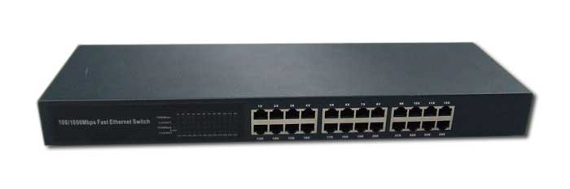
Disclaimer
- We spared no efforts to make sure that the information in this manual is correct and complete. However no liability is accepted for any errors or omissions. Everest Electronics reserves the right to change the specifications of the hardware and software described in this manual without prior notice.
- No part of this manual may be reproduced, transmitted or translated in any language in any form, by any means, without the prior written permission of Everest Electronics Ltd.
- Everest Electronics makes no warranties for damages resulting from corrupted or lost data due to a mistaken operation or malfunction of the product, the software, personal computers or peripheral devices.

Everest® is a registered trademark.
Other names or products not mentioned above may be registered trademarks or trademarks of their respective owners.

Copyright © 2007 Everest Ltd. All rights reserved.

NS-24PR User manual

Introduction

Thank you for buying the Everest® Metal 24 ports rack mount switch 10/100Mbps N-Way switch! This manual will help you install and use it properly.
The 10/100Mbps switch is the perfect way of integrating 10Mbps Ethernet and 100Mbps Fast Ethernet devices. All 24 ports are auto speed negotiating, and have automatic MDI/MDI-X crossover detection, so you don't have to worry about the cable type. Each port independently negotiates for best speed and half- or full-duplex mode, for up to 200Mbps of bandwidth per port. Fast store-and-forward switching prevents damaged packets from being passed on into the network.

Features

- 24 10/100BASE-T Ethernet ports
- Supports Full/Half duplex transfer mode for 10/100Mbps
- Supports Auto-Negotiation for 10/100Mbps
- 19" rack mountable

Specification

- Complies with IEEE 802.3, IEEE 802.3u
- Supports Auto-MDI/MDIX for each port
- Supports Store-and-Forward switching method
- Supports Wire-speed and non-blocking performance
- Supports Address learning and aging
- Supports Broadcast Storm Filtering Control
- Supports a wide range of data rate for both egress and ingress
- Embeds 1.5 Mb packet buffer
- Supports up to 4K MAC addresses entries

Package contents

- 10/100Mbps switch
- AC power cord
- Manual

Front Panel LEDs

Power LED
This green indicator illuminates when the Switch is receiving power.

Link/Act
This green indicator illuminates steadily when a port is connected to a station successfully, If this green indicator is blinking, it indicates that a port is transmitting or receiving data on the network.

10/100M
This green indicator illuminates steadily when a port is connected to a 100Mbps Fast Ethernet station. Otherwise, the indicator is off when a port is connected to a 10Mbps Ethernet Device.

Back Panel Features

The power connector is located on the back panel of the switch.

AC Power Connector
This a three pronged connector that support the power cord. Plug in the female connector of the provided power cord into this connector, and the male into a power outlet. Supported input voltages range from 100~240V AC at 50~60Hz.

Connecting Network Devices

To connect network devices to the Switch, follow these instructions:
- Make sure all the devices you will connect to the Switch are powered off
- Connect a Category 5/5e Ethernet network cable to one of the numbered ports on the Switch
Note: Use Category 5e Ethernet network cables for your Gigabit connections.
- Connect the other end to a PC or other network devices
- Repeat steps 2 and 3 to connect additional devices
- Connect the supplied power adapter to the power port on the Switch's back panel
Note: Make sure you use the power adapter included with the Switch. Using a different power adapter may result in damage to the Switch.
- Plug the other end of the adapter into an electrical outlet
- Power on the devices connected to the Switch. Each active port's corresponding LED will light up on the Switch

